PROJECT FINAL REPORT

1. INTRODUCTION
1.1 PROjeCT OveRvIew
Cosmetic Insights: Navigating Cosmetics Trends and Consumer Insights with Tableau is a data analytics and visualization project focused on uncovering patterns in consumer behavior and market dynamics within the cosmetics industry. The cosmetics market is growing rapidly, driven by changing consumer preferences, product innovations, and increased competition. As a result, there is a growing need for brands to leverage data to stay relevant and responsive.
This project utilizes Tableau to design interactive dashboards that help analyze various dimensions of cosmetics data, including product rankings, price ranges, skin-type suitability, brand performance, and label distribution. These visualizations enable users—such as marketing professionals, product developers, and business analysts—to identify emerging trends, understand consumer needs, and make strategic decisions.
By transforming raw datasets into meaningful visual stories, Cosmetic Insights supports evidence-based decision-making. It bridges the gap between data and action, allowing stakeholders to adapt quickly to market changes, enhance customer satisfaction, and drive business growth.
The project also demonstrates the practical application of data visualization tools in real-world scenarios, showcasing how clear visual insights can simplify complex datasets and offer a competitive edge in industries driven by consumer perception.

1.2 PURPOse
The primary purpose of this project is to analyze cosmetics-related data and transform it into interactive, visual insights using Tableau. With the cosmetics industry becoming more consumer-driven and competitive, understanding market trends and consumer behavior is critical for brands aiming to improve their product strategies, marketing efforts, and customer engagement.
This project is intended to serve as a decision-support system that empowers stakeholders—including brand managers, marketers, and analysts—to explore and interpret data across various dimensions such as brand popularity, skin-type compatibility, price range, product labels, and customer rankings. These insights help stakeholders make informed decisions based on patterns, trends, and correlations found in the data.
Beyond decision-making, the project also aims to:
- Improve accessibility to complex datasets through simple, interactive visual dashboards.
- Support product innovation by identifying gaps in consumer needs and market trends.
- Enable faster responses to shifts in consumer preferences and feedback.
- Demonstrate the effective use of data visualization tools (Tableau) in solving real-world business challenges.
In summary, the project aims to bridge the gap between raw data and actionable insights, helping cosmetic brands remain agile, customer-focused, and data-driven.

2. IDeATION PHAse

2.1 PROblem sTATemeNT
Create a problem statement to understand your customer's point of view. The Customer Problem Statement template helps you focus on what matters to create experiences people will love. A well-articulated customer problem statement allows you and your team to find the ideal solution for the challenges your customers face. Throughout the process, you’ll also be able to empathize with your customers, which helps you better understand how they perceive your product or service.
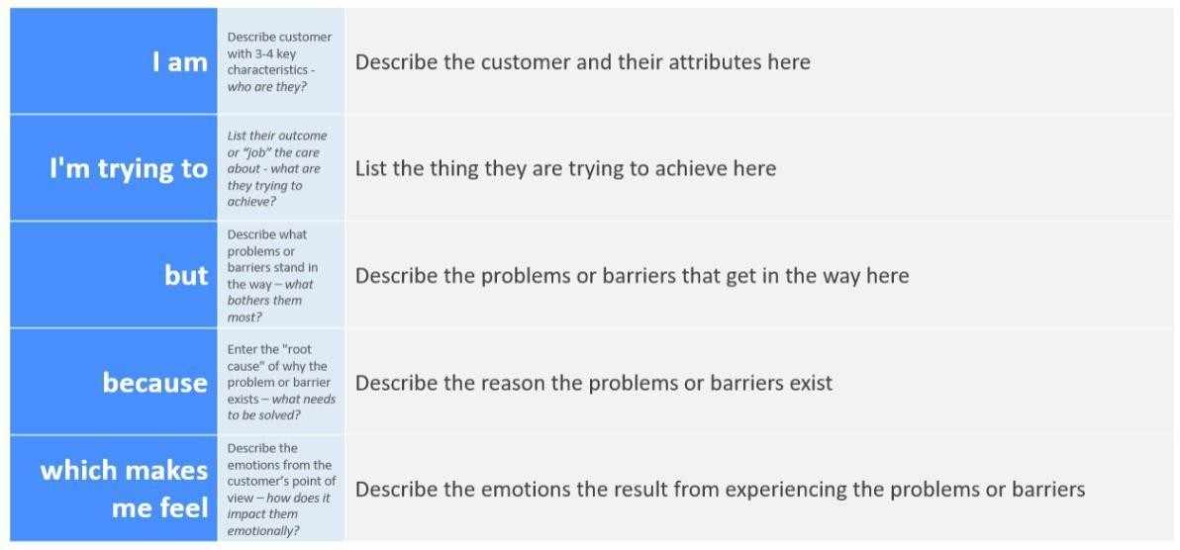
EXAMPLE:
Problem  Statement  (PS) | I am (Customer) | I’m trying to | But | Because | Which makes me  feel
PS-1 | A skincare focused student | Find acne safe cosmetics | Can’t tell which  products suit my skin | Product info is unclear | confused
PS-2 | Working woman  with sensitive skin | Buy cruelity free makeup | Can’t compare brands easily | Ethical is not shown visually | frustated

2.2 emPATHy mAP CANvAs
An empathy map is a simple, easy-to-digest visual that captures knowledge about a user’s behaviours and attitudes. It is a useful tool to helps teams better understand their users.
Creating an effective solution requires understanding the true problem and the person who is experiencing it. The exercise of creating the map helps participants consider things from the user’s perspective along with his or her goals and challenges.
EXAMPLE:
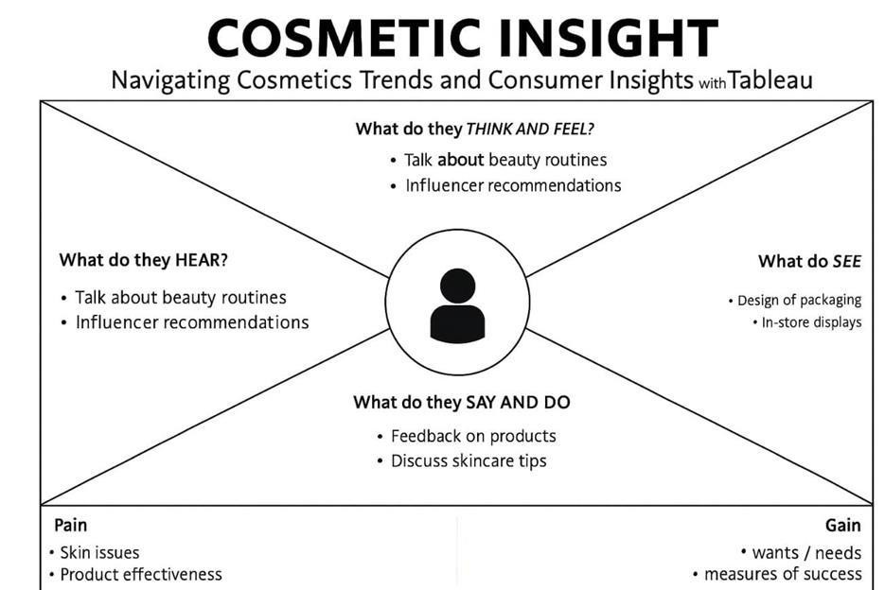
2.3 bRAINsTORmINg
Brainstorming provides a free and open environment that encourages everyone within a team to participate in the creative thinking process that leads to problem solving. Prioritizing volume over value, out-of-the-box ideas are welcome and built upon, and all participants are encouraged to collaborate, helping each other develop a rich amount of creative solutions.
Step-1: Team Gathering, Collaboration and Select the Problem Statement
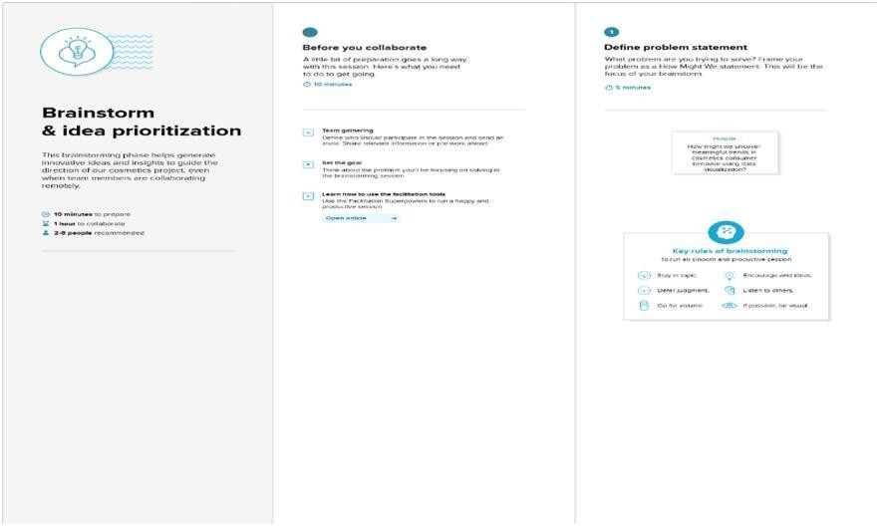
Step-2: Brainstorm, Idea Listing and Grouping
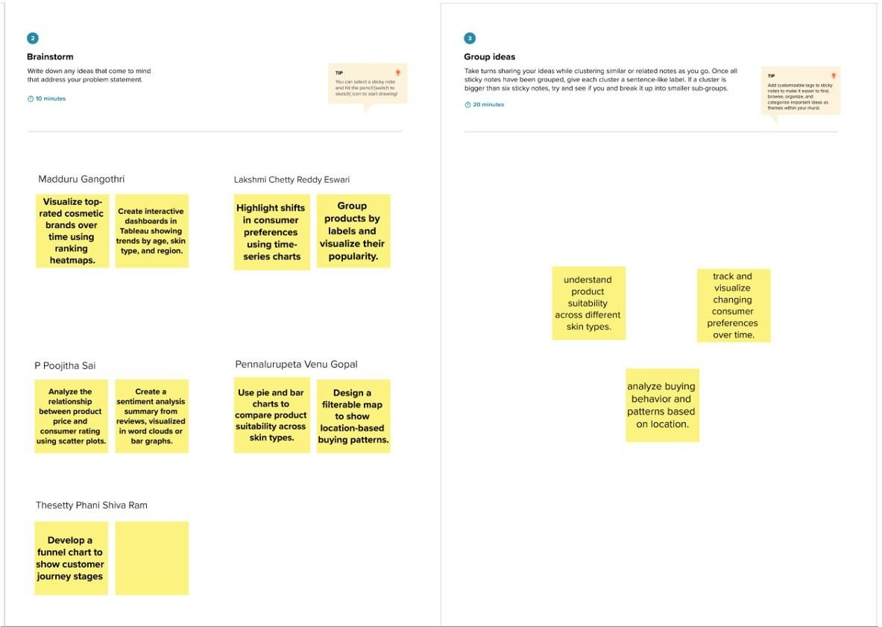
Step-3: Idea Prioritization
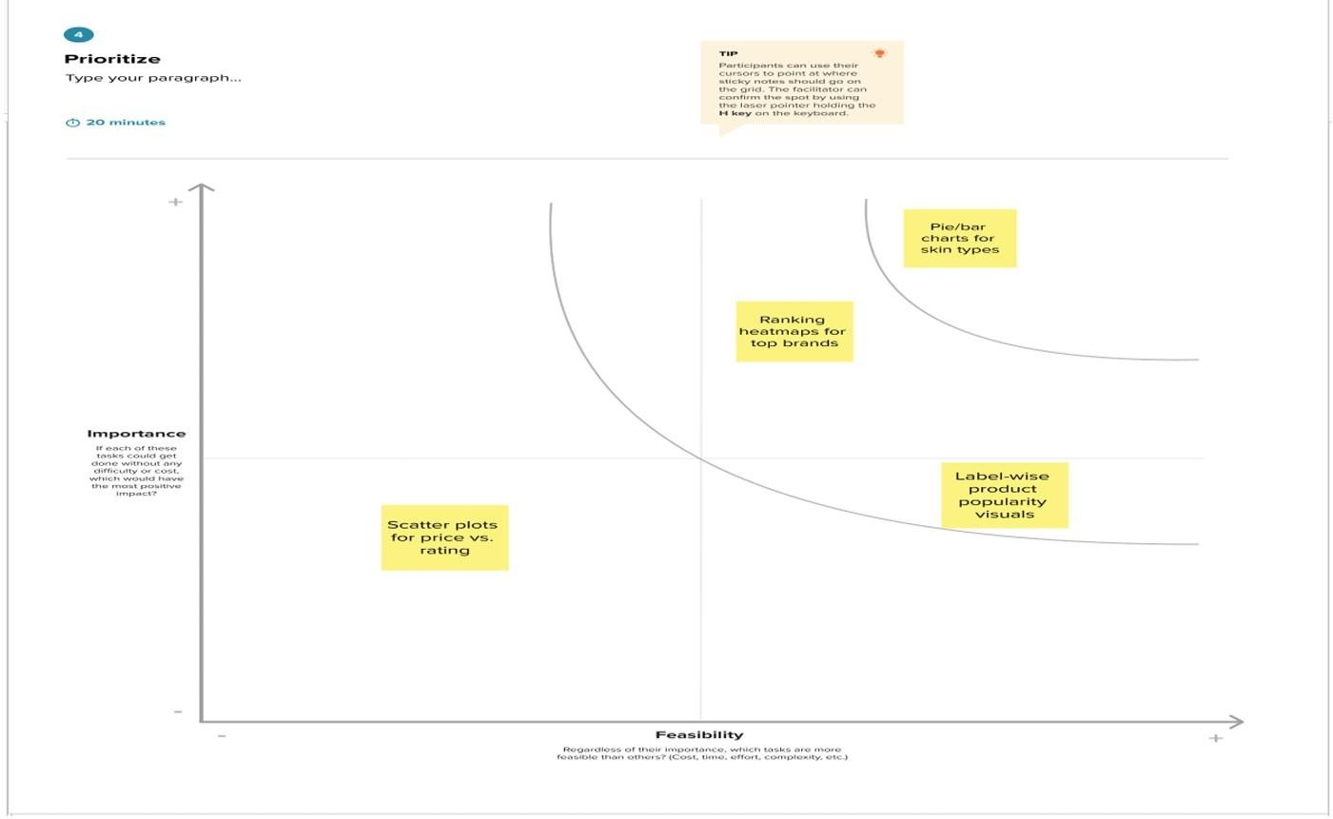

3. ReQUIRemeNT ANAlysIs
3.1 CUsTOmeR jOURNey mAP
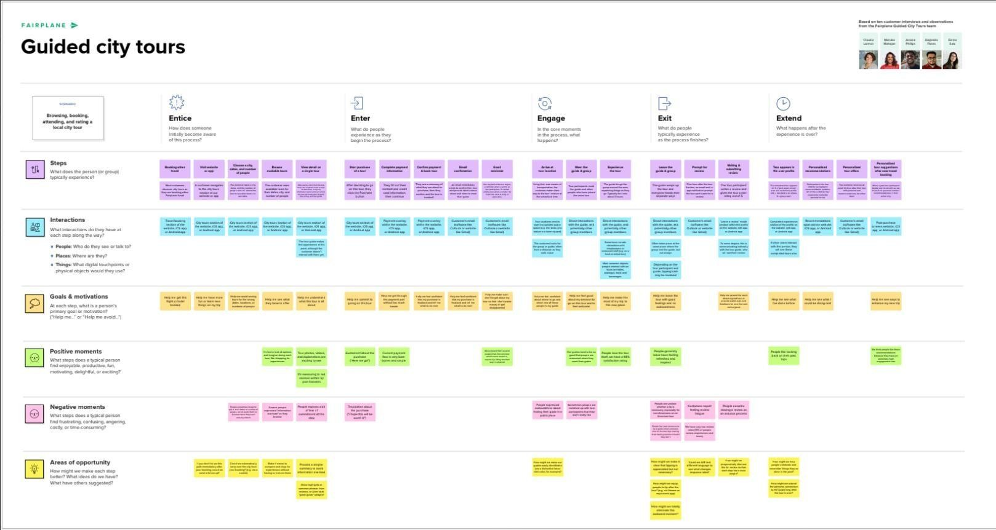
3.2 sOlUTION ReQUIRemeNT
Functional Requirements:
Following are the functional requirements of the proposed solution.
FR  No. | Functional Requirement  (Epic) | Sub Requirement (Story / Sub-Task)
FR-1 | User Registration | Registration through Form  Registration through Gmail  Registration through LinkedIN
FR-2 | User Confirmation | Confirmation via Email  Confirmation via OTP
FR-3 | Dashboard & Insights | View cosmetic trends (charts, graphs) Filter by skin type, brand, price  View rankings by label and brand
FR-4 | Product  Recommendation | Input skin type/preferences Get suggested products based on suitability Show top-rated products for selected criteria

Non-functional Requirements:
Following are the non-functional requirements of the proposed solution.
FR  No. | Non-Functional  Requirement | Description
NFR-  1 | Usability | User interface should be simple, intuitive, and accessible to users with minimal technical knowledge.
NFR-  2 | Security | User data must be protected using encryption, secure login, and access controls.
NFR-  3 | Reliability | System should function correctly under defined conditions with minimal downtime or failures.
NFR-  4 | Performance | Application should load insights and charts within 2 3 seconds and handle multiple user requests efficiently.
NFR-  5 | Availability | Application should be available 24/7 with minimal maintenance-related downtime.

3.3 DATA FlOw DIAgRAm
Data Flow Diagrams:
A Data Flow Diagram (DFD) is a traditional visual representation of the information flows within a system. A neat and clear DFD can depict the right amount of the system requirement graphically. It shows how data enters and leaves the system, what changes the information, and where data is stored Example: (Simplified)
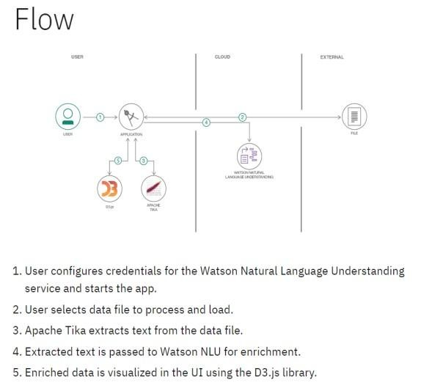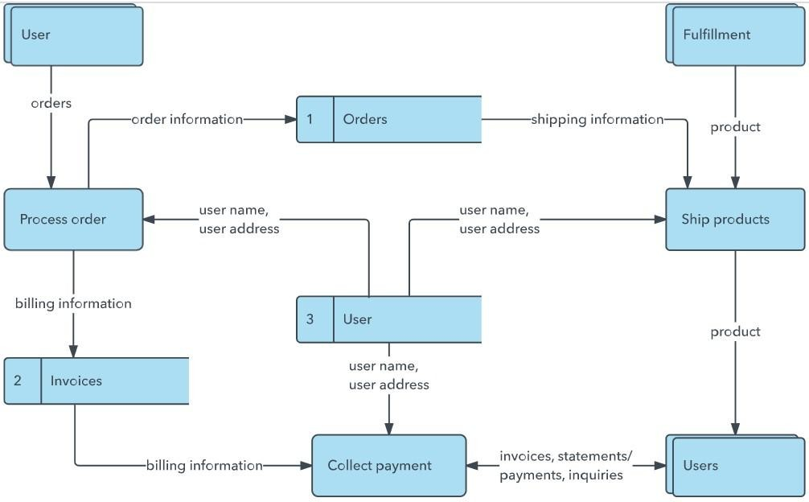

User Stories
Use the below template to list all the user stories for the product.

User Type | Functional  Requirement  (Epic) | User  Story  Number | User Story / Task | Acceptance  criteria | Priority | Release
Customer  (Mobile user) | Registration | USN-1 | As a user, I can register for the application by entering my email, password, and confirming my password. | I can access my account / dashboard | High | Sprint-1
 |  | USN-2 | As a user, I will receive confirmation email once I have registered for the application | I can receive confirmation email & click confirm | High | Sprint-1
 |  | USN-3 | As a user, I can register for the application through  Facebook | I can register & access the dashboard with Facebook Login | Low | Sprint-2
 |  | USN-4 | As a user, I can register for the application through  Gmail | I can log in with  Gmail | Medium | Sprint-1
 | Login | USN-5 | As a user, I can log into the application by entering email & password | I can access dashboard after correct login | High | Sprint-1
 | Dashboard | USN-6 | As a user, I can view trending products, ingredient safety scores, and personalized suggestions | I can see curated products based on skin profile | High | Sprint-2
Customer  (Web user) | Order History | USN-7 | As a user, I can view previous orders and reorder products | I see past orders  and reorder easily | Medium | Sprint-3
User Type | Functional  Requirement  (Epic) | User  Story  Number | User Story / Task | Acceptance  criteria | Priority | Release
Customer  Care  Executive | Query handling | USN-8 | As a customer care exec, I can view and reply to user queries submitted through the contact form. | I can reply to user inquiries and see resolution status | Medium | Sprint-3
Administrator | Product  Management | USN-10 | As an admin, I can add/edit/delete product listings in the catalog. | Products reflect on user side after changes | high | Sprint-2

3.4 TeCHNOlOgy sTACk
Technical Architecture: The Deliverable shall include the architectural diagram as below and the information as per the table1 & table 2 Example: Order processing during pandemics for offline mode.
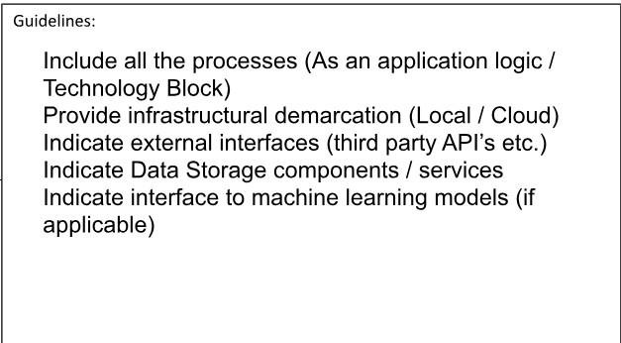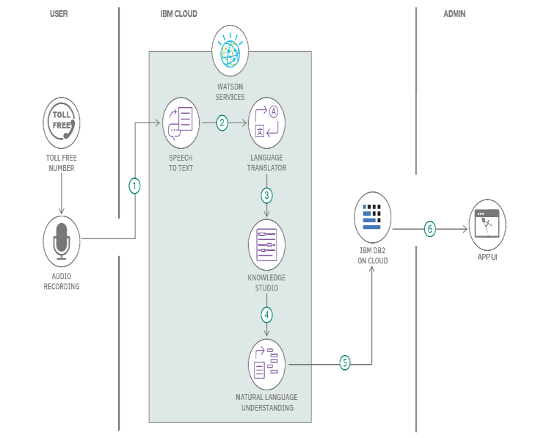

Table-1 : Components & Technologies:
S.No | Component | Description | Technology
1. | User Interface | How user interacts with application e.g.  Web UI, Mobile App, Chatbot etc. | HTML, CSS, JavaScript / Angular Js / React Js etc.
2. | Application Logic-1 | Logic for a process in the application | Java / Python
3. | Application Logic-2 | Logic for a process in the application | IBM Watson STT service
4. | Application Logic-3 | Logic for a process in the application | IBM Watson Assistant
5. | Database | Data Type, Configurations etc. | MySQL, NoSQL, etc.
6. | Cloud Database | Database Service on Cloud | IBM DB2, IBM Cloudant etc.
7. | File Storage | File storage requirements | IBM Block Storage or Other Storage  Service or Local Filesystem
8. | External API-1 | Purpose of External API used in the application | IBM Weather API, etc.
9. | External API-2 | Purpose of External API used in the application | Aadhar API, etc.
10. | Machine Learning  Model | Purpose of Machine Learning  Model | Object Recognition Model, etc.
11. | Infrastructure (Server  / Cloud) | Application Deployment on  Local System / Cloud Local Server Configuration:  Cloud Server Configuration : | Local, Cloud Foundry, Kubernetes, etc.

Table-2: Application Characteristics:
S.No | Characteristics | Description | Technology
1. | Open-Source Frameworks | List the open-source frameworks used | Technology of  Opensource framework
2. | Security  Implementations | List all the security / access controls implemented, use of firewalls etc. | e.g. SHA-256, Encryptions,  IAM  Controls, OWASP etc.
3. | Scalable  Architecture | Justify the scalability of architecture (3 – tier,  Micro-services) | 3-Tier Architecture  (Frontend – Logic – DB)
4. | Availability | Justify the availability of application (e.g. use of load balancers, distributed servers etc.) | Tableau Server / IBM Cloud / Load Balancer (if  scaled)
5. | Performance | Design consideration for the performance of the application (number of requests per sec, use of Cache, use of CDN’s) etc. | Redis (if large-scale),  Tableau Extracts, CDN

4. PROjeCT DesIgN

4.1 PROblem sOlUTION FIT
Problem – Solution Fit Template:
The Problem-Solution Fit simply means that you have found a problem with your customer and that the solution you have realized for it actually solves the customer’s problem. It helps entrepreneurs, marketers and corporate innovators identify behavioral patterns and recognize what would work and why
Purpose:
- Solve complex problems in a way that fits the state of your customers.
- Succeed faster and increase your solution adoption by tapping into existing mediums and channels of behavior.
- Sharpen your communication and marketing strategy with the right triggers and messaging.
- Increase touch-points with your company by finding the right problem-behavior fit and building trust by solving frequent annoyances, or urgent or costly problems.
- Understand the existing situation in order to improve it for your target group.

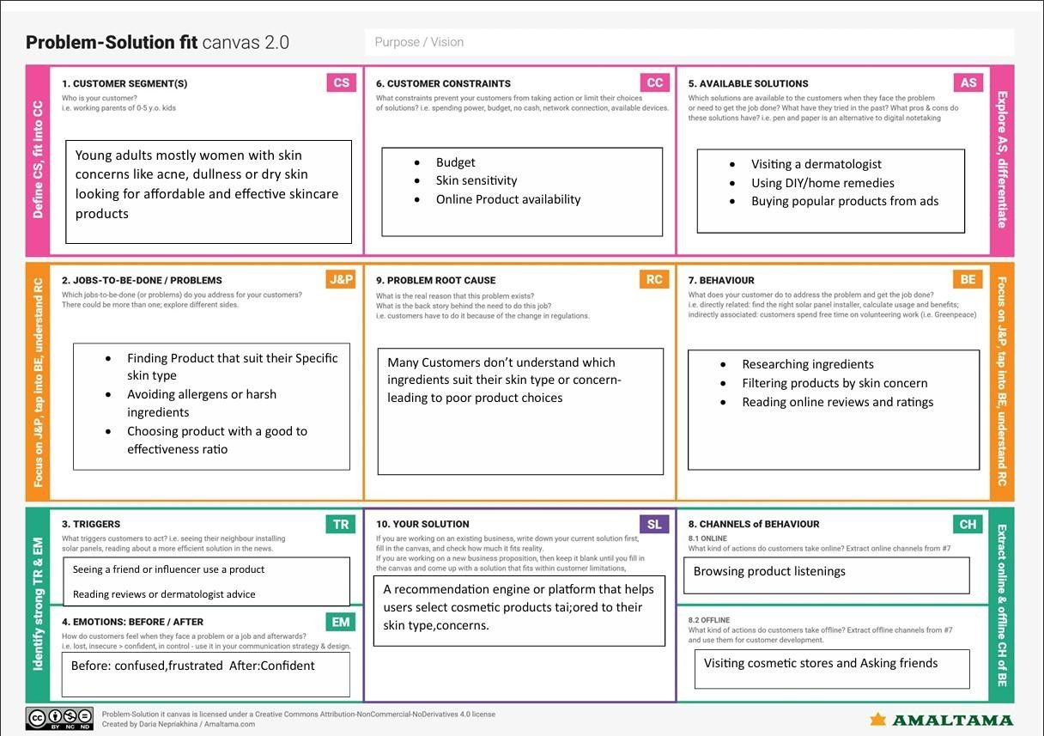
  - PROPOseD sOlUTION
Proposed Solution :
Project team shall fill the following information in the proposed solution template.
S.No. | Parameter | Description
1. | Problem Statement (Problem to be solved) | The cosmetic industry lacks data-driven approaches to understand evolving consumer preferences, trend patterns, and product effectiveness. Businesses often miss timely insights into customer behavior, leading to ineffective product development and marketing strategies.
2. | Idea / Solution description | This project uses Tableau to analyze and visualize cosmetic product trends and consumer insights. By leveraging real-world datasets, it highlights user preferences, product popularity, and demand patterns. Dashboards and visualizations enable companies to make strategic decisions regarding product launches, marketing, and customer engagement.
3. | Novelty /  Uniqueness | Unlike generic dashboards, this project combines trend analytics, user sentiment, and sales performance into a single interactive visualization platform. It integrates multiple KPIs (Key Performance Indicators) to offer a holistic view, empowering both cosmetic brands and consumers with realtime, actionable insights.
4. | Social Impact /  Customer  Satisfaction | The solution enhances consumer satisfaction by aligning product offerings with actual needs and preferences. It also empowers consumers with transparency. For brands, it reduces wastage, increases personalization, and promotes sustainability by focusing on what customers actually want.
5. | Business Model  (Revenue Model) | The solution can be monetized as a B2B SaaS model where cosmetic companies subscribe to access analytics dashboards. Additional revenues can be generated via: Insight reports for product innovation and market expansion Custom dashboard creation Data consulting
6. | Scalability of the  Solution | The framework is scalable across geographies, brands, and product categories. It can be extended to include social media analytics, influencer trends, and real-time sales data. The same model can also be applied to other consumer goods industries.

  - sOlUTION ARCHITeCTURe
Solution Architecture:
Solution architecture is a complex process – with many sub-processes – that bridges the gap between business problems and technology solutions. Its goals are to:
- Find the best tech solution to solve existing business problems.
- Describe the structure, characteristics, behavior, and other aspects of the software to project stakeholders.
- Define features, development phases, and solution requirements.
- Provide specifications according to which the solution is defined, managed, and delivered.

Example - Solution Architecture Diagram:
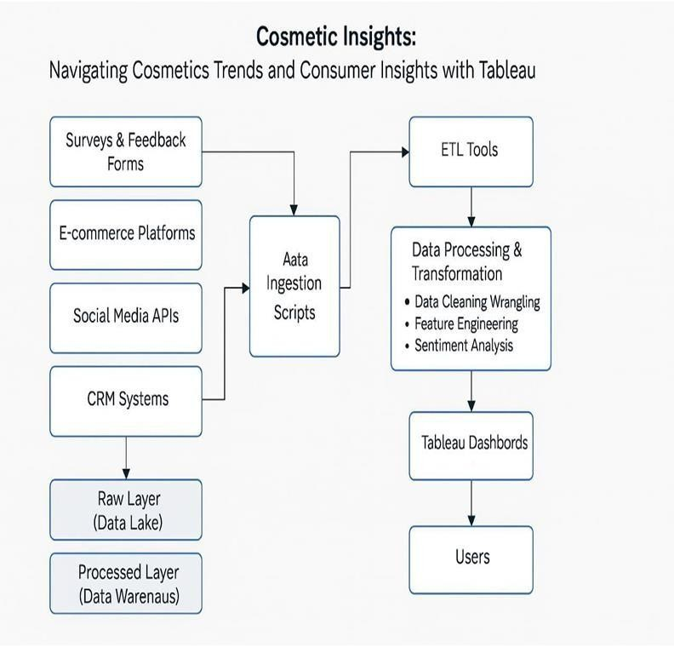

5. PROjeCT PlANNINg & sCHeDUlINg
5.1 PROjeCT PlANNINg

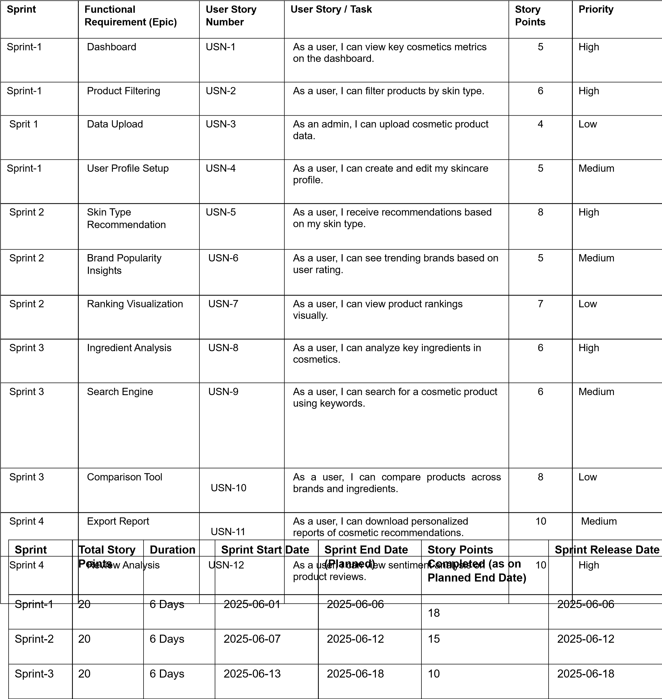
Product Backlog, Sprint Schedule, and Estimation (4 Marks)
Use the below template to create product backlog and sprint schedule

Project Tracker, Velocity & Burndown Chart: (4 Marks)
- FUNCTIONAl AND PeRFORmANCe TesTINg
Sprint-4 | 20 | 6 Days | 2025-06-19 | 2025-06-24 | 20 | 2025-06-24

  - PeRFORmANCe TesTINg

Model Performance Testing:
Project team shall fill the following information in model performance testing template.

S.No. | Parameter | Screenshot / Values
1. | Data Rendered | The dataset titled "cosmetics.csv" was successfully imported into Tableau. It contains multiple attributes related to cosmetic products, such as labels, brand names, skin suitability, pricing, ratings, and user reviews.  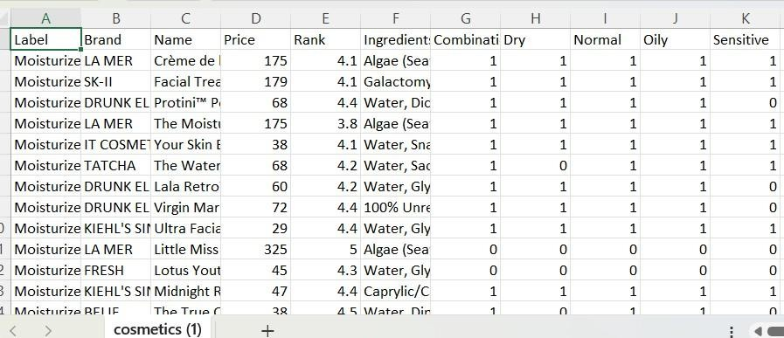
2. | Data Preprocessing | - The dataset was cleaned and prepared before visualization.  - Missing values were checked and handled appropriately, such as removing empty rows or filling null values where needed.  - Unwanted characters and duplicates were removed to ensure accurate analysis in Tableau.
3. | Utilization of Filters | - Brand Filter  - Label Filter  - Skin Suitability Filter

4. | Calculation fields Used | - Label Count  - Count of Names  - Average of price  - Skin Suitability Count
5. | Dashboard design | No of Visualizations / Graphs – 9  1.Top Brands 2.Label Count 3.Price vs Brand 4.Sensitive Skin Suitability  5.Noraml Skin Suitability 6.Oily Skin Suitability  7.Dry Skin Suitability 8.Brand vs Ranking 9.Label vs Ranking  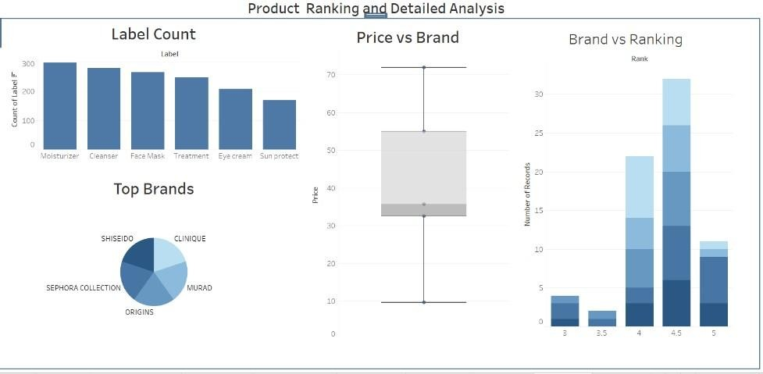  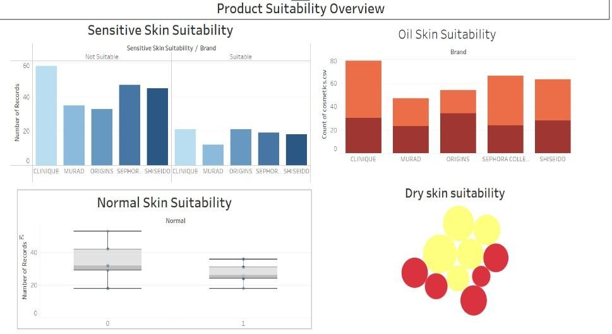
6 | Story Design | No of Visualizations / Graphs -6  1.Top Brands 2.Different Labels of 3.Price of Different 4.Skin Suitability 5.Brand Ranking 6.Label Ranking  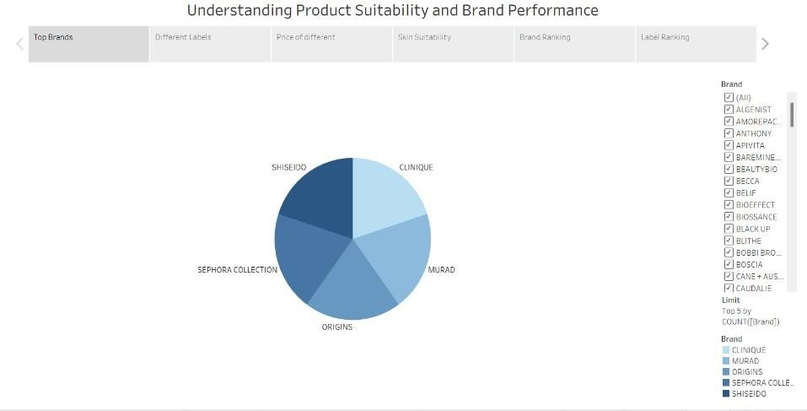

- ResUlTs

  - OUTPUT sCReeNsHOTs

Dashboard 1
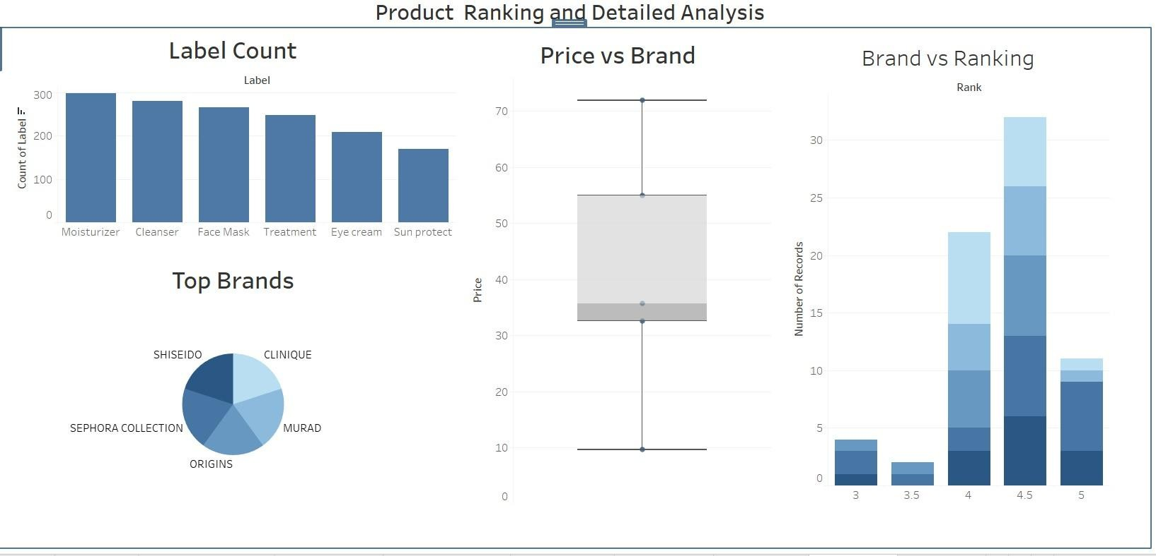

Dashboard 2
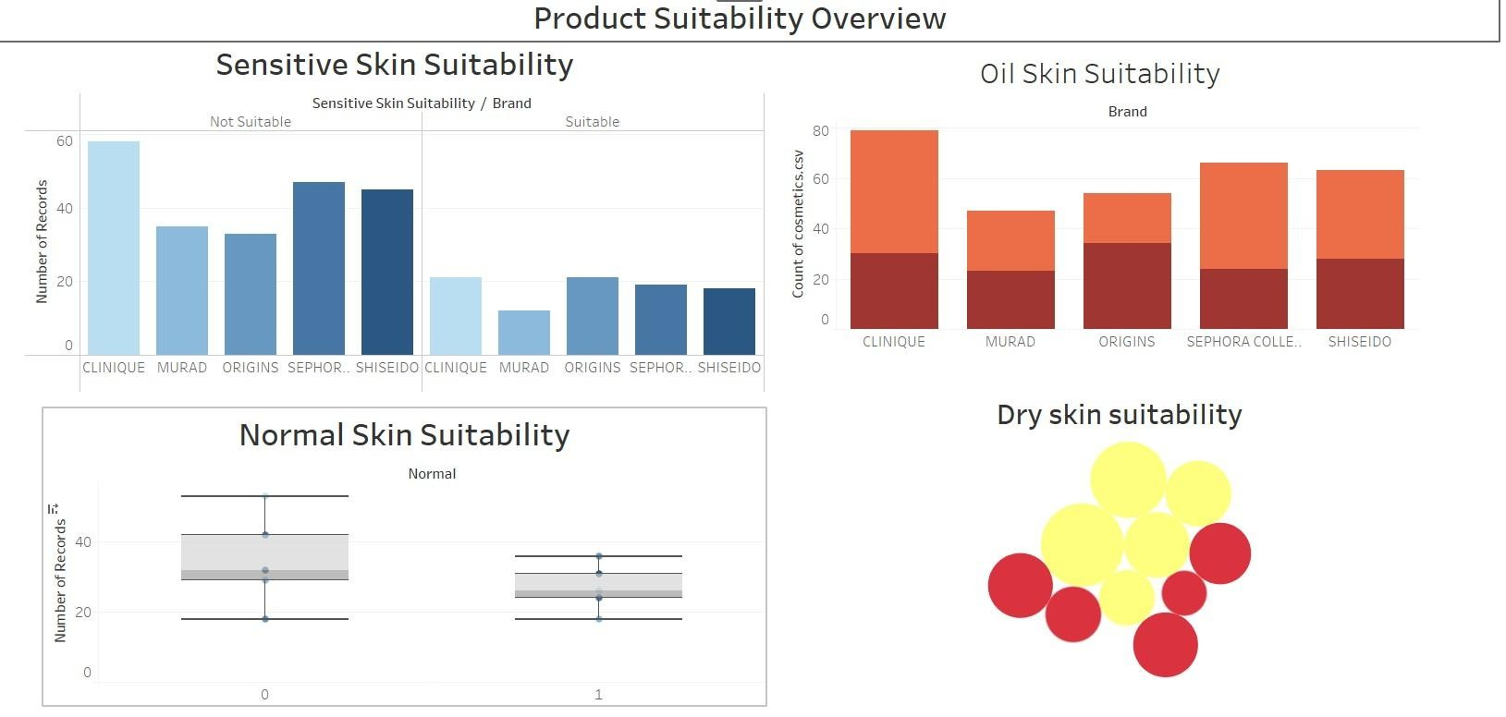

Story
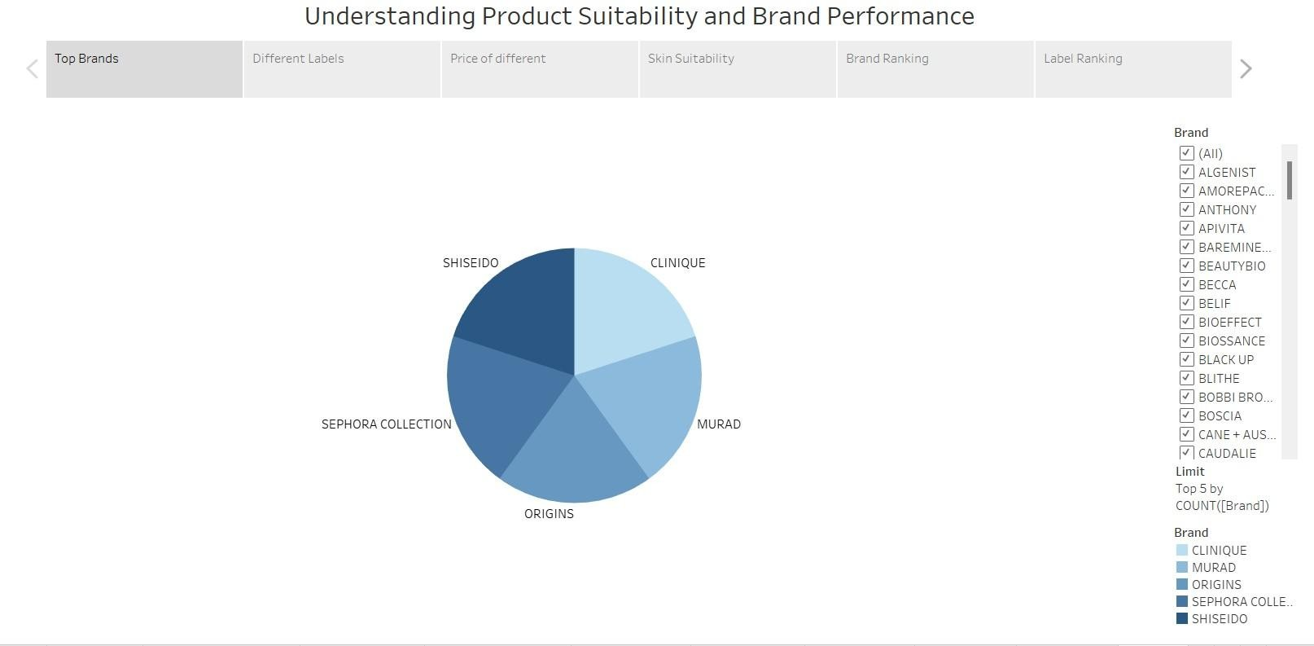

8. ADvANTAges & DIsADvANTAges

8.1 Advantages
1. Data-Driven Decision Making
Enables stakeholders to make informed decisions based on real-time data insights.

2. Interactive Dashboards
Tableau dashboards provide dynamic visualizations that allow users to explore data in a user-friendly manner.

3. Improved Market Understanding
Helps identify consumer preferences, top-performing brands, and product suitability across different skin types.
- Supports Product Innovation
Insights can guide product development and formulation strategies by highlighting gaps and trends.
- Time Efficiency
Reduces the time needed to interpret large datasets by converting them into intuitive visuals.

6. Scalability
Dashboards can be updated with new data to reflect current trends without reworking the entire project.

8.2 Disadvantages
1. Data Dependency
The quality of insights is limited by the quality and completeness of the dataset used.

2. Tool Limitations
Tableau Public has certain feature limitations compared to the paid version (e.g., data refresh, privacy controls).
3. Learning Curve
New users may require time to understand and navigate Tableau’s interface effectively.

4. Limited Predictive Capabilities
Basic Tableau dashboards focus on descriptive analytics; advanced predictive modeling requires integration with other tools.

5. Internet Requirement
If hosted on Tableau Public or cloud services, access requires a stable internet connection.

9. CONClUsION

The project "Cosmetic Insights: Navigating Cosmetics Trends and Consumer Insights with Tableau" demonstrates the powerful role of data visualization in understanding and responding to consumer behavior within the cosmetics industry. As the industry continues to expand and become more consumerdriven, brands are under increasing pressure to adapt quickly to changing preferences, maintain product quality, and stay ahead of competition. This project addresses these challenges by transforming raw, complex data into visually appealing and interactive dashboards using Tableau.
By analyzing various dimensions such as brand popularity, product pricing, skin-type suitability, and label distribution, the project provides a comprehensive view of market dynamics. These insights help stakeholders make informed decisions related to marketing, product development, and customer targeting. The visualizations created allow users to identify trends, spot patterns, and extract valuable information without needing advanced technical skills.
Additionally, the project emphasizes the importance of real-time analytics and interactive tools in supporting agile business decisions. Whether it is monitoring declining interest in specific products, addressing customer concerns, or identifying emerging trends, the dashboards serve as a reliable tool for both strategic planning and operational improvement.
In conclusion, this project successfully showcases how tools like Tableau can bridge the gap between data and decision-making. It lays a strong foundation for future enhancements, such as incorporating predictive analytics, expanding datasets, or integrating with customer feedback platforms. With continuous updates and scalability, Cosmetic Insights has the potential to be a valuable asset for businesses seeking to thrive in a data-driven and consumer-centric market.

10. FUTURe sCOPe
The Cosmetic Insights project provides a solid foundation for visualizing cosmetics industry data, but there is significant potential to expand and enhance the platform in the future. As the industry and data sources evolve, the project can grow in the following ways:

1. Integration with Real-Time Data Sources
Incorporating live data feeds from social media, e-commerce platforms, or customer review sites can enable real-time trend analysis and faster response to market shifts.

2. Predictive Analytics and Machine Learning
Adding machine learning models can help forecast future trends, predict consumer preferences, and support product recommendations based on historical behavior.

3. Personalized Consumer Dashboards
Creating user-specific dashboards where consumers can input their skin type or preferences to receive tailored product suggestions and trend updates.

4. Mobile-Friendly Dashboards
Optimizing Tableau dashboards for mobile and tablet views can improve accessibility and usability for brand managers and marketers on the go.

5. Integration with External APIs
Connecting the platform with APIs such as ingredient analysis tools, product safety databases, or competitor analytics can enrich the insight depth.

6. Enhanced Security and Data Privacy
As more personal or sensitive data is integrated, implementing stronger security measures and access controls will become essential.

7. Expansion to Other Beauty Segments
The model can be extended to other domains such as skincare, haircare, and fragrance to create a broader beauty insights platform.

11. APPeNDIX

DATAseT lINk https://www.kaggle.com/datasets/kingabzpro/cosmetics-datasets
gITHUb & PROjeCT DemO lINk
Github –
https://github.com/syamalakunapareddy1/Cosmetic-Insights-Navigating-Cosmetics-Trends-and-Consumer-Insights-with-Tableau
Project Demo -
https://drive.google.com/file/d/17SmNnxl8QxbBO1Wj1mmioIUyk96ROiAx/view?usp=drive_link

